Solution Architecture

Date | 20 March 2026
Team ID | SWTID-2026-4885
Project Name | Credit Card Approval System
Maximum Marks | 5 Marks

Solution Architecture Diagram:
Provide a high-level visual representation of your solution's architecture. Use the structural layout to map out your Presentation Layer, Application Layer, and Data Layer. Create a Component Description Table to know about each layer and technologies used in that layer clearly.

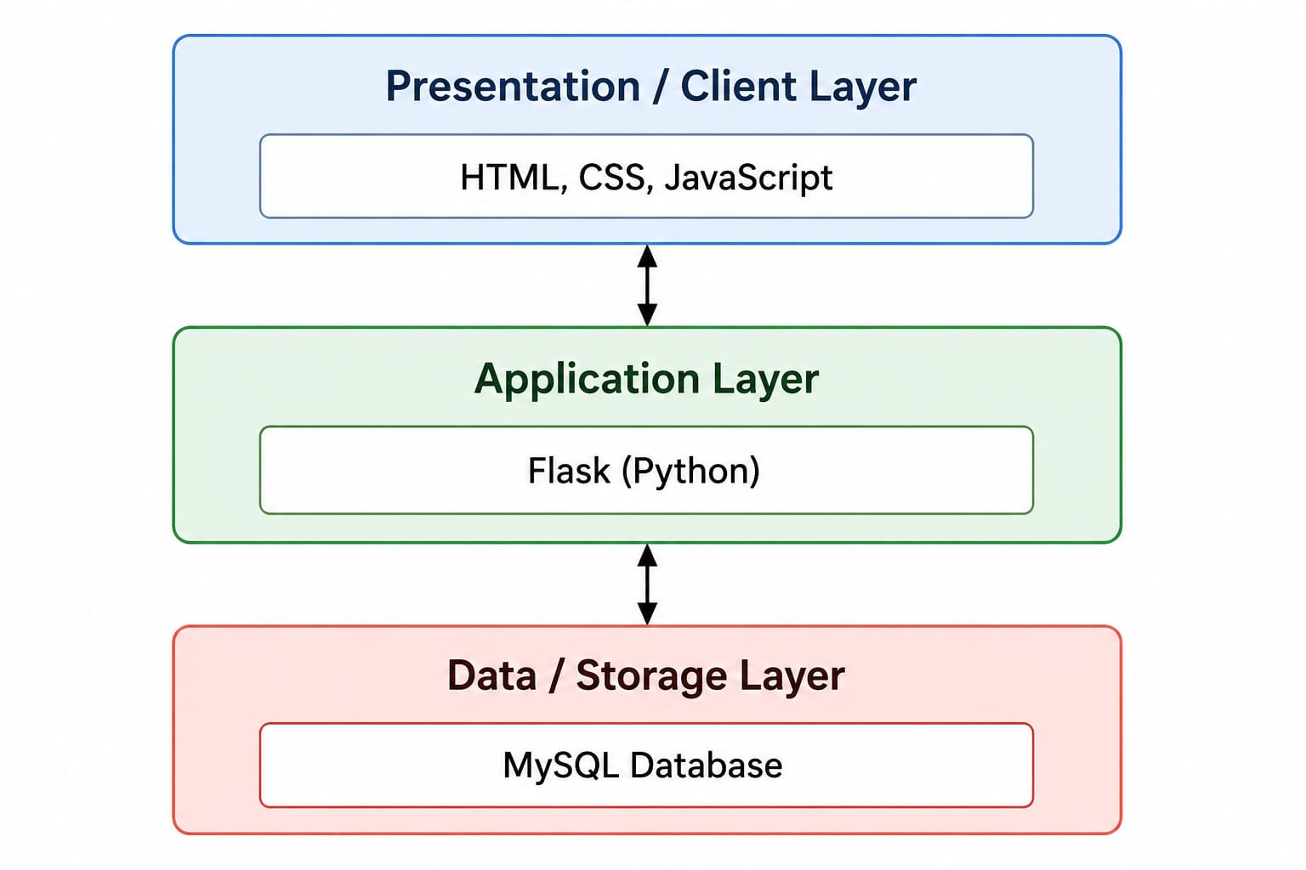

Component Description Table

Component Name | Description / Role in Architecture | Technologies Used
Presentation Layer | Provides the user interface where customers enter their personal and financial details and view the credit card eligibility prediction result. | HTML, CSS, JavaScript
Application Layer | Receives customer input, processes the request, sends the data to the AI & ML model for prediction, retrieves the result, and communicates with the database. | Python, Flask, Scikit-learn, Pandas, NumPy, Joblib

